Coding for Pocket PC

# Code to get the output on LCD Screen

**sudo rm -rf LCD-show**

**git clone https://github.com/goodtft/LCD-show.git**

**chmod -R 755 LCD-show**

**cd LCD-show/**

**sudo ./LCD35-show**

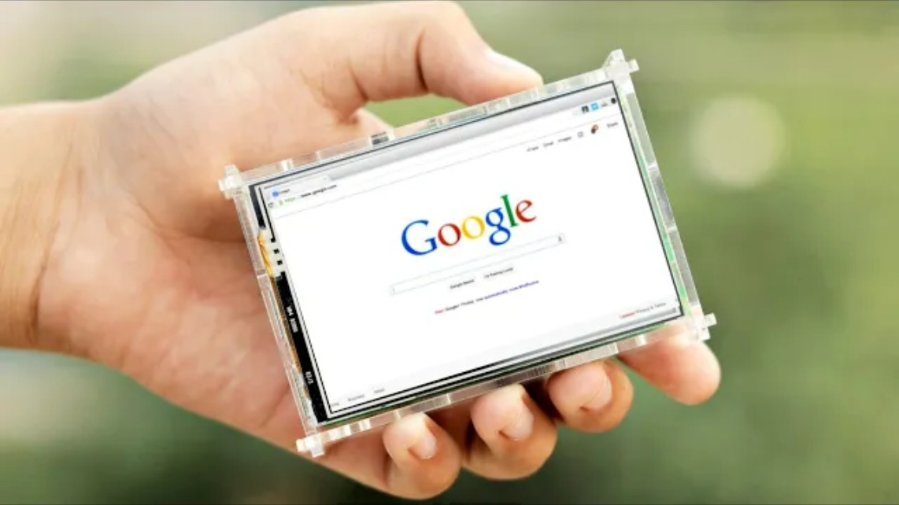

# Code to get on-screen keyboard

**sudo apt-get install matchbox-keyboard**